

**LOW Level Design**

Author: Team  
Creation Date: 2024-06-06

Last Updated by:   
Last Updated:

Revision: V1.0

Document Control

Information

|  |
| --- |
| File name |
| Building a Timesheet application for NWS. |

Change Record

|  |  |  |  |
| --- | --- | --- | --- |
| Date | Author | Revision | Change Reference |
| 2024-06-06 | 1.Supriya Melkunde  2.Vishal Wankhade | 1.0 | Initial version |
|  |  |  |  |
|  |  |  |  |
|  |  |  |  |
|  |  |  |  |

Internal and external Reviewers

|  |  |
| --- | --- |
| Name | Department |
| Yogesh Oza |  |
| Dinesh Prajapati |  |
|  |  |

Distribution

|  |  |  |
| --- | --- | --- |
| Copy No. | Name | Location |
|  |  |  |
|  |  |  |
|  |  |  |

Table of Contents

Document Control i

1. Overview 3

a. Document Purpose: 3

2. Modules 3

3. Standard Object 3

a. Emplyee Details 3

4. UI design 6

**5. Modules :** Field Name & datatypes

6. Flow Diagram

# Overview

### Document Purpose:

# Employee logs in and navigates to the profile section. They view and update their profile photo (optional) and personal details like date of birth, city, state, address, country, phone number and financial information like bank name & accunt number. After saving changes, the system confirms the successful update of the profile information.

# Modules

Employee details

# Standard Object

## Employee Details

|  |  |  |  |
| --- | --- | --- | --- |
| End User | Requirement | Action | Activities |
| Employee | |  | | --- | |  |  |  | | --- | | Log in to the system | | Enter email and password, click "Login" | System authenticates credentials, grants access |
| Employee | Access profile Page | Navigate to profile section | System displays current profile information |
| Employee | Update profile photo (optional) | Upload new photo, click "Save" | System updates profile photo |
| Employee | Update date of birth | Enter new date of birth, click "Save" | System saves updated date of birth |
| Employee | Update city | Enter new city, click "Save" | System saves updated city |
| Employee | Update state | Enter new state, click "Save" | |  | | --- | |  |  |  | | --- | | System saves updated state | |
| Employee | Update address | Enter new address, click "Save" | System saves updated address |
| Employee | Update country | Enter new country, click "Save" | System saves updated country |
|  |  |  |  |
| Employee | Update phone number | Enter new phone number, click "Save" | System saves updated phone number |
| Employee | Update bank name | Enter bank name, click "Save" | System saves updated bank name |
| Employee | Update account number | Enter account number, click "Save" | System saves updated account number |
| Employee | View salary | View salary | System Shows updated salary |
| Employee | View hire date | View hire date | - |
| System | Confirm updates | |  | | --- | |  |  |  | | --- | | Display success message | | System shows confirmation message to the employee |

# UI Design

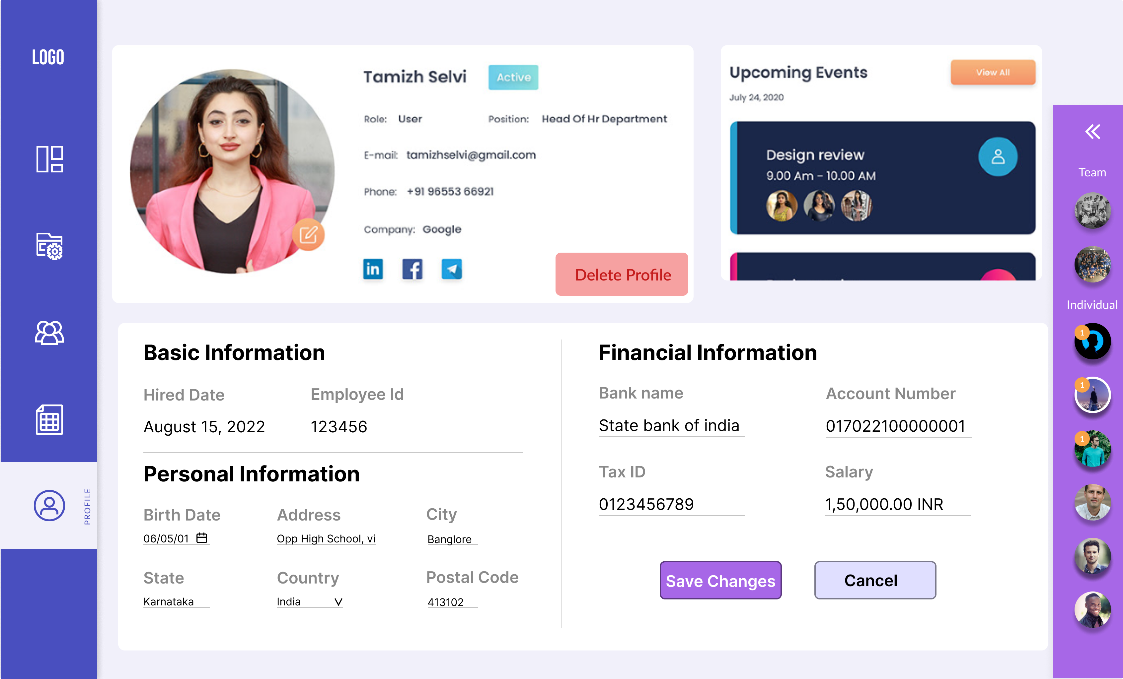

# Modules (Field name & DataTypes):

|  |  |
| --- | --- |
| **Field Name** | **Datatype** |
| FullName | String |
| dateOfBirth | DateTime |
| Address | String |
| City | String |
| State | String |
| Country | String |
| postalCode | Number |
| phoneNumber | Number |
| bankName | String |
| accountNumber | Number |
| taxID | String |
| Salary | Float |
| hireDate | DateTime |

# Flow Diagram:

